Modifying a Pro Mini for Low Power Operation
For trackers being built to run on 2 x AAA Lithium batteries (3V), we will need to remove the regulator from the Pro Mini. The two LEDs on the Pro Mini should also be removed as they just waste power.

The easiest way to remove the regulator and not damage the board is to use a very sharp scalpel to cut through the regulator leads at the point they join the regulator body.

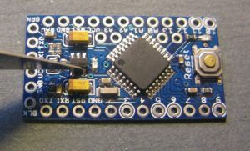

Removing the LEDs can be tricky, so its easier to remove the series resistors for the LEDs instead. This version of Pro Mini also has a resistor feedback network for the regulator across VCC, these consume power so should be removed. Just push the resistors aside with a soldering iron. The picture shows the Pro Mini with unwanted parts removed, locations of the removed components are circled in red.

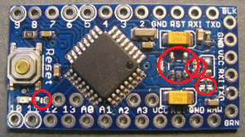

We need to reprogram the brown out level for the processor, as default the extended fuse is set to 0x05 on the above Pro Minis giving a brown out level detect of 2.7V. This is OK if your using the 3.3V regulator with an external supply, but a little close for a processor running at 3V. I used AVRDUDESS with a USBTiny programmer to reset the fuse to 0x06, giving a 1.8V brownout level.

Stuart Robinson
September 2018

